E - Commerce Website

Created by Ankit Sonawane

**SYNOPSIS**

**Title:**

E-commerce Website

**Description:**

This project is aimed at developing a Website that depicts online shopping for a clothing brand name ATTIRE. Online Shopping can be used to improve the marketing of the company’s products. This Website involves some major the features of the online shopping.

**Objective of the project:**

The software will help in easy maintaining and updating products in the Website for the administrator. Also quick and easy comparison of different products for the customers. This system will reduce the load and time required to administer the data including Product details. This will provide a fast and centralized data management system that will be beneficial for the company. Since information is the key of success for every organization today hence, Website develop by us for our client (ATTIRE pvt. ltd.) uses Information Technology to work faster and with 100 percent efficiency.

**Hardware and Software Requirements:**

On Client’s Side

Hardware:

Processor type:

• Minimum: Core 2 Duo or higher.

• Monitor: VGA Monitor.

RAM: Minimum: 2 GB or more.

Processor speed: 1 GHz or higher.

Hard disk: 20 GB or more.

Software:

• Any operating system.

• Browser (e.g. Google Chrome, Mozilla Firefox).

• Internet Connectivity.

**INDEX PAGE**

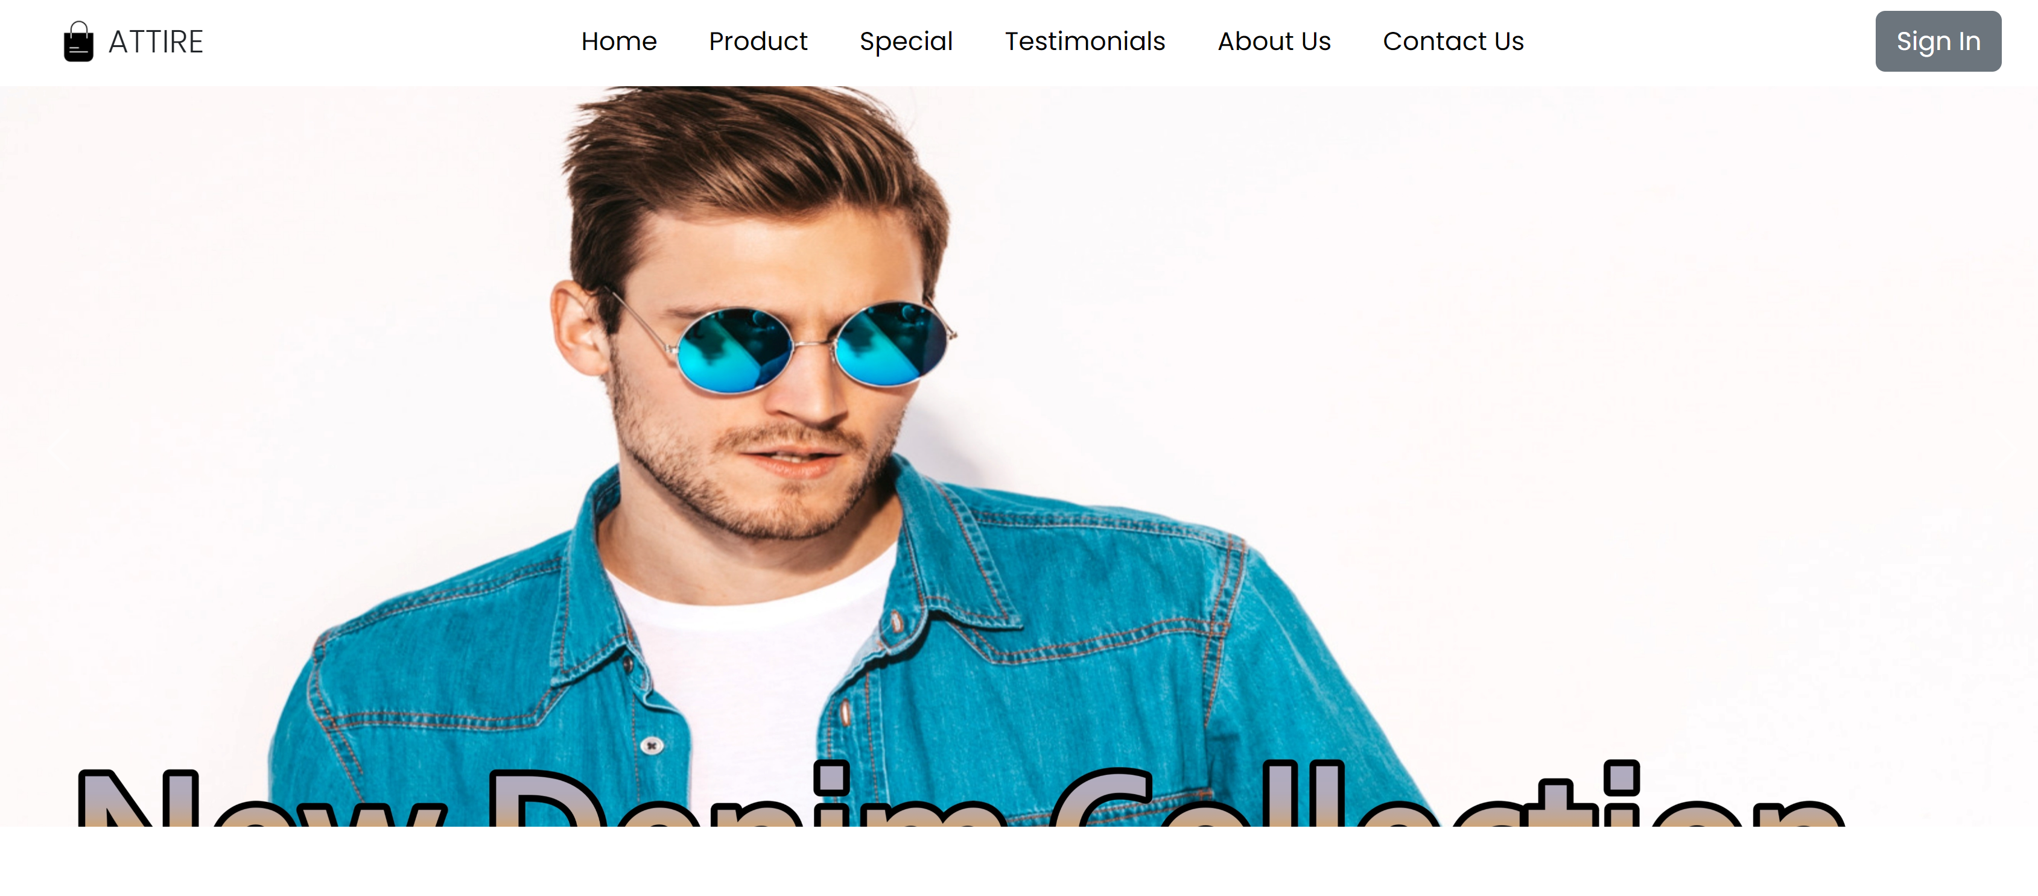

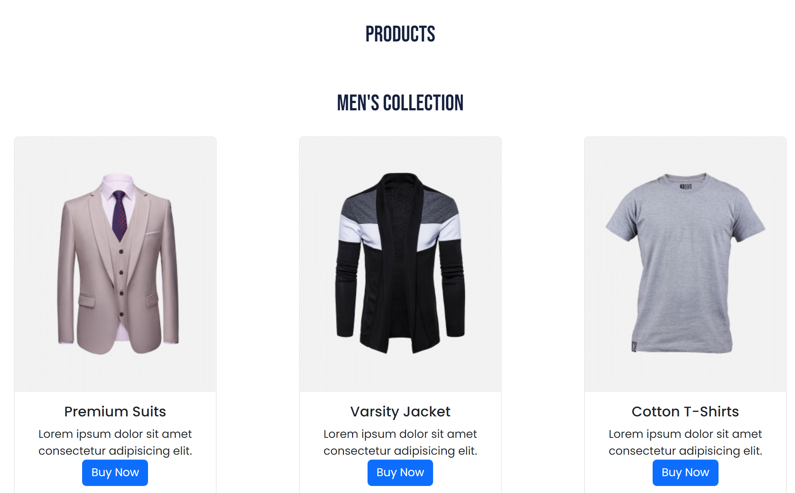

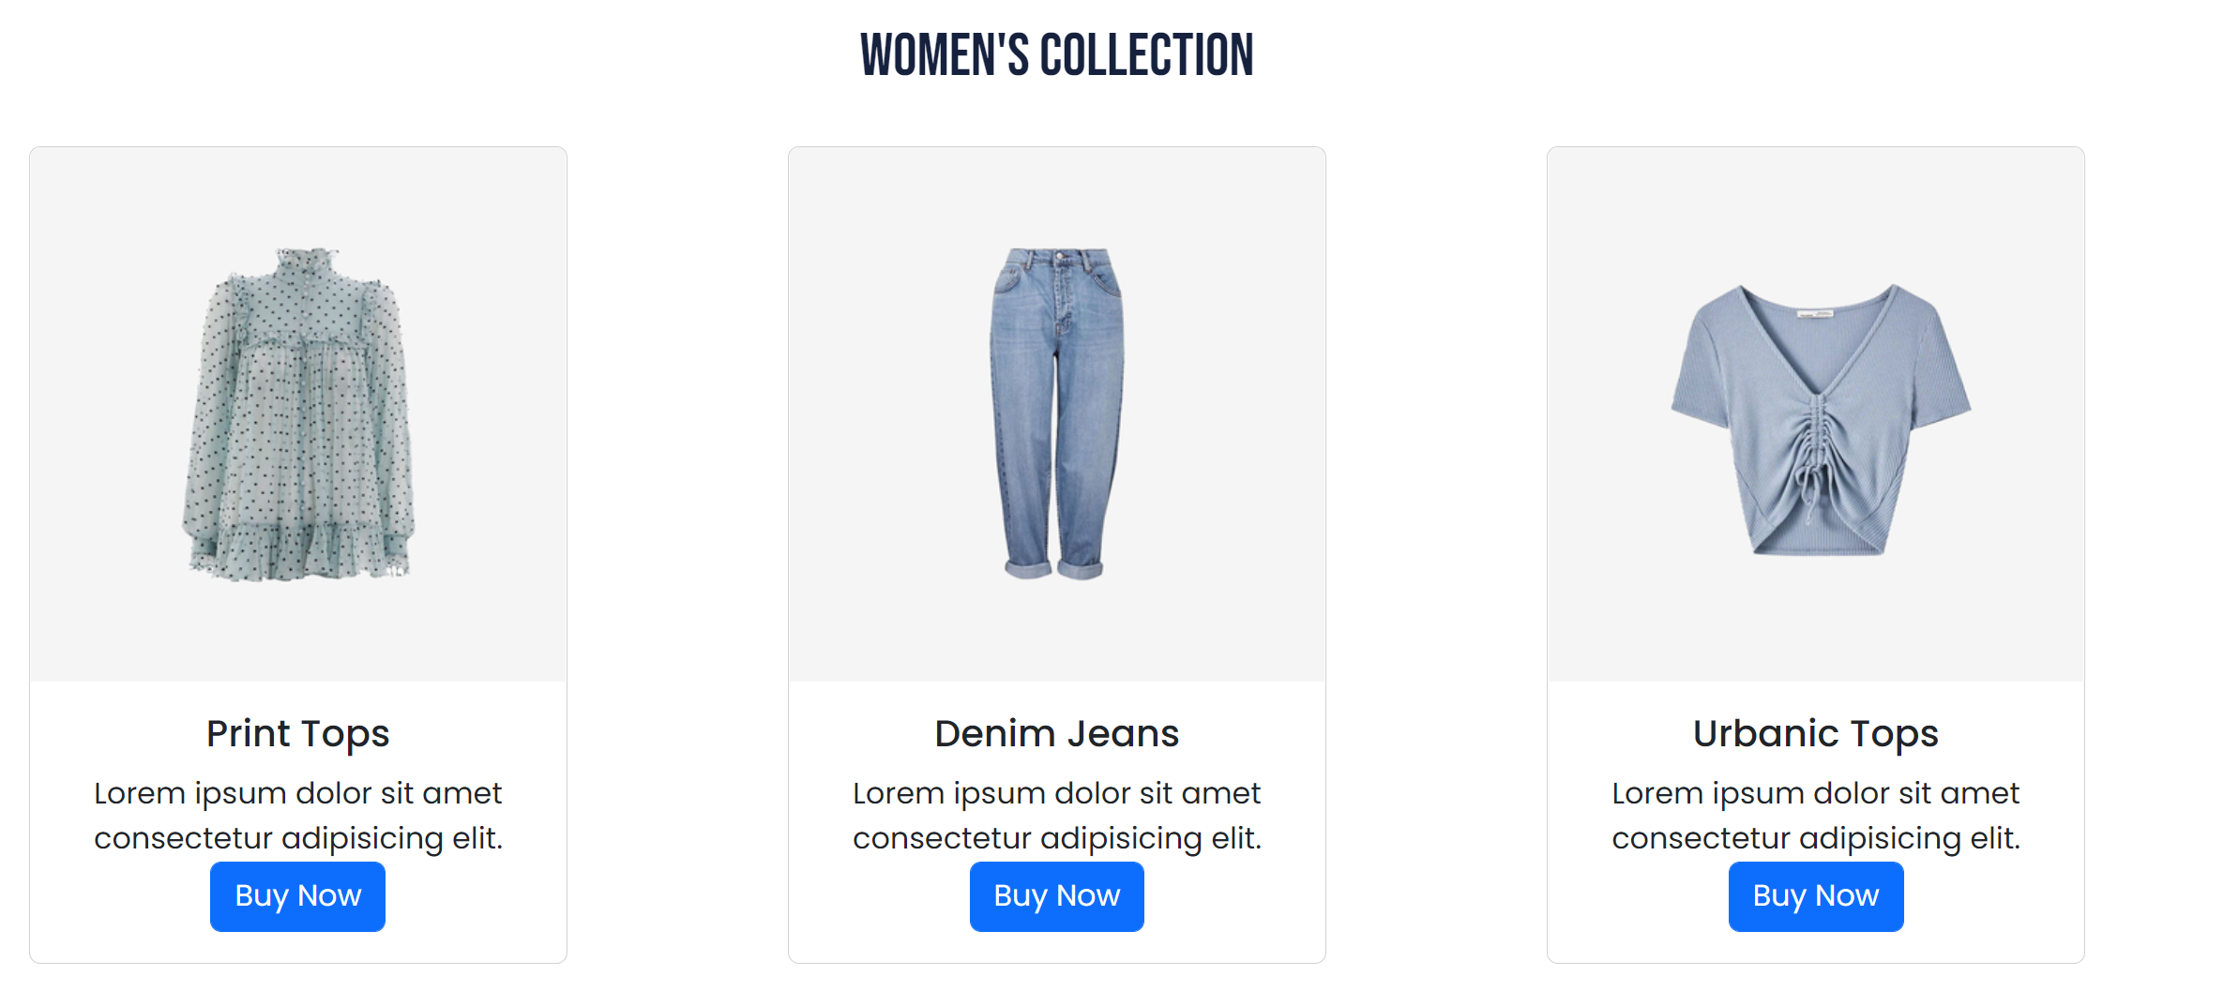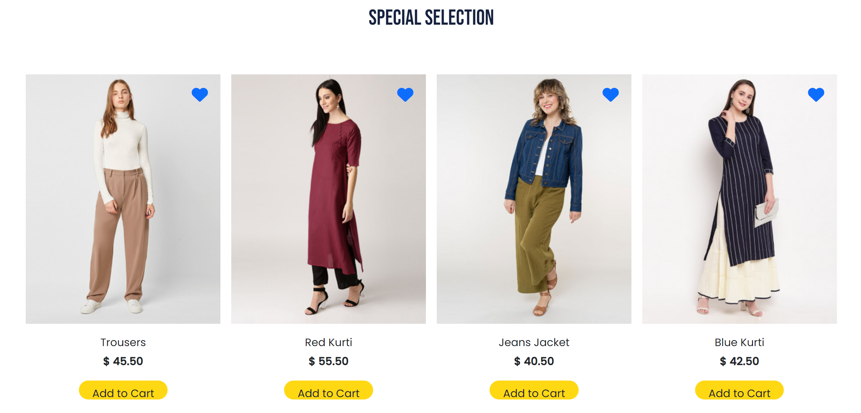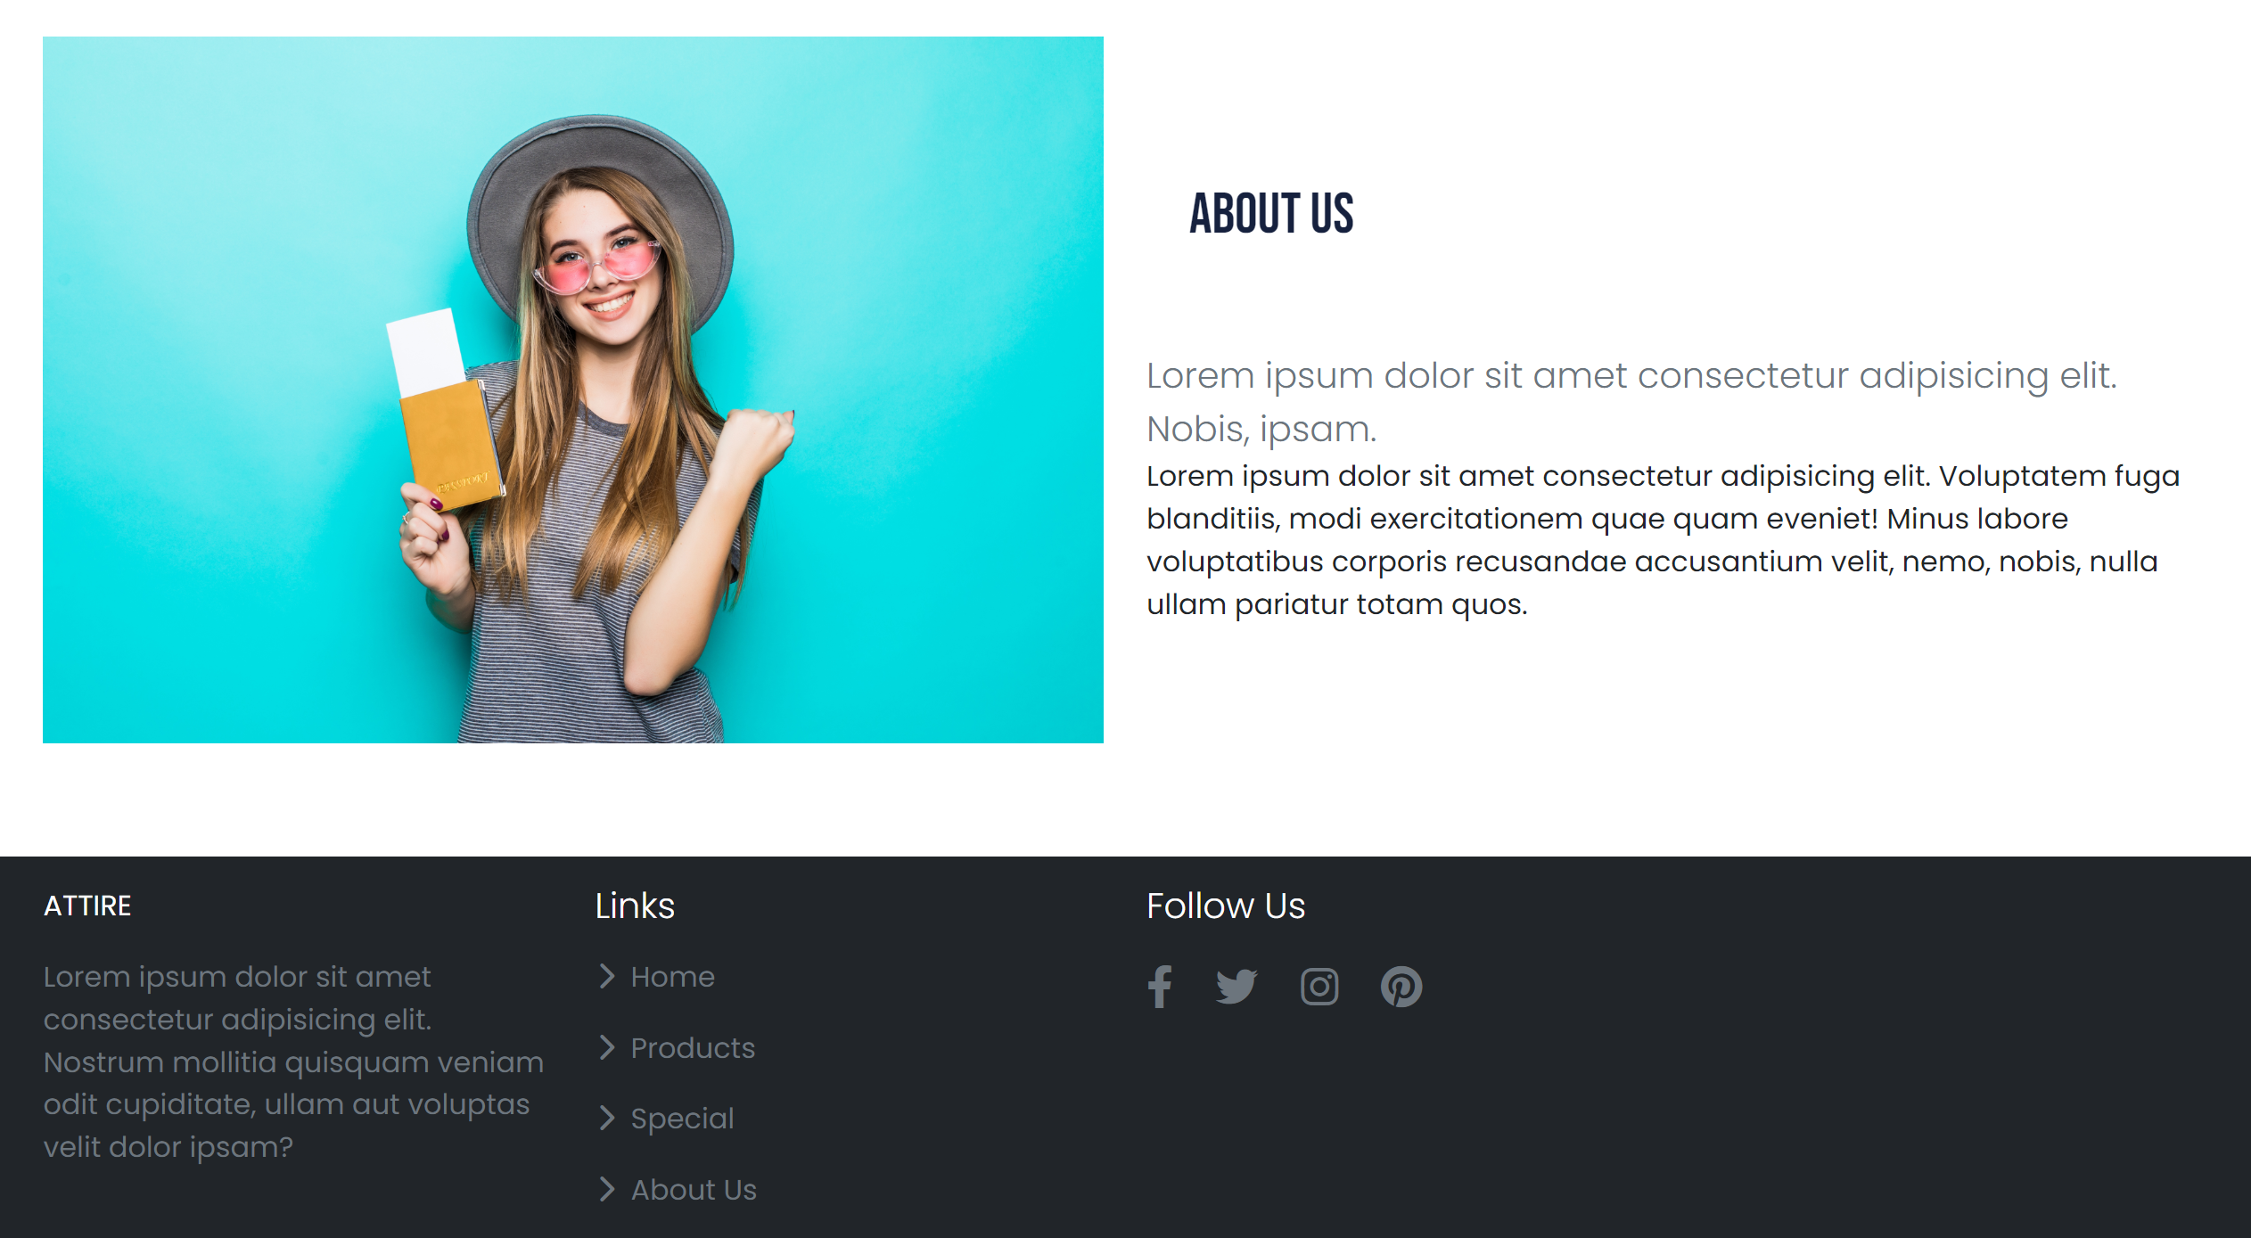

**REGISTRATION DETAILS:**

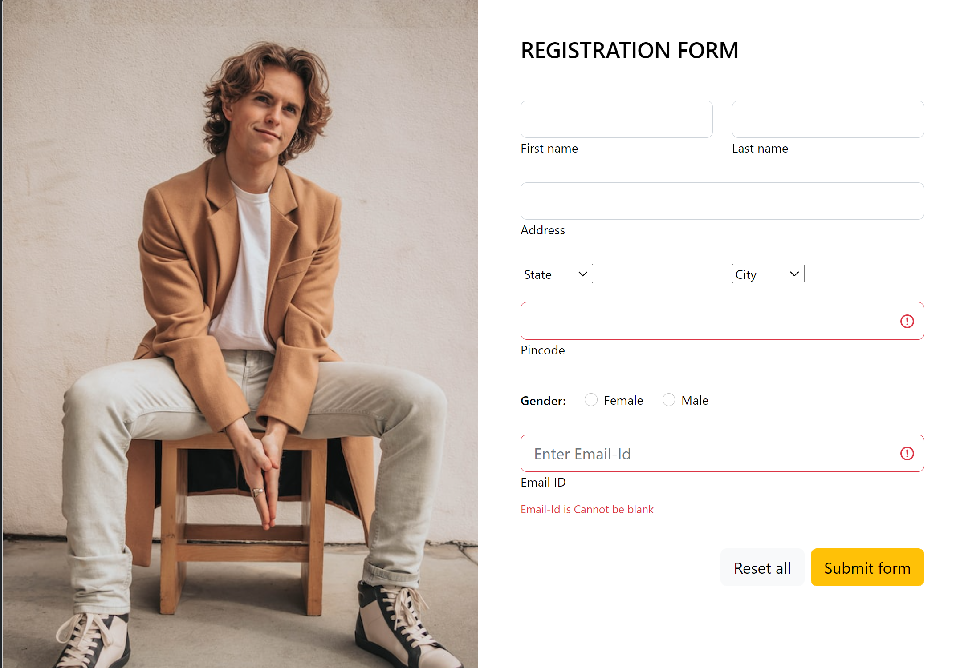

**CONTACT US:**

